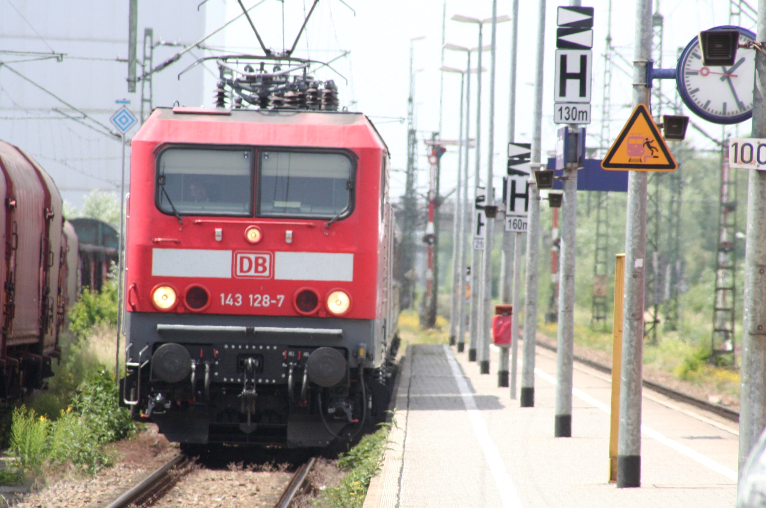

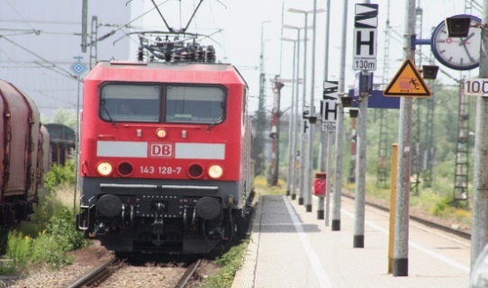
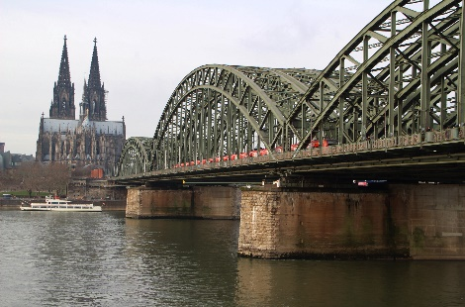
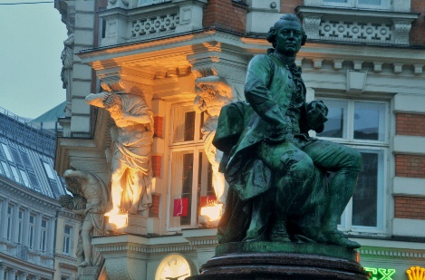
A FAIRY TALE JOURNEY THROUGH GERMANY
In the Footsteps of the Brothers Grimm
8 days – 7 nights

INCLUSIONS
- Private transfers airport/hotel/airport
- Transfers from train station to the hotel in Cologne, Bremen, Hamburg, Berlin and Munich.
- 10 nights in selected hotels (3*** or 4****) including breakfast.
- City tour in Hamburg and Berlin with professional local tour guides.
- Full day guided tour to Potsdam
- Full day guided tour to Neuschwanstein and Linderhof Castles
- Entrance to the Miniature Wonderland Museum in Hamburg
- Harbour boat tour in Hamburg
NOT INCLUDED
- Train tickets in the routes detailed in the itinerary
- International or national flights
- Transfer from Hotel to the train stations
- Personal expenses
- Tips for drivers, guides and porters
- Meals and drinks not mentioned here.
- Health insurance and others.

PRICES PER PERSON
IN DOUBLE OCCUPANCY
EUR 1.698.-
Surplus Single Room EUR 508.-

Train ticket bundle: from 263.- EUR

DEPARTURES 2024

Everyday from
January through December

Do you want to organize your group or customize your travel plan? Please contact us anytime.

Embark on a whimsical journey through Germany as we trace the enchanting footsteps of the Brothers Grimm -Wilhelm and Jacob- the literary maestros who brought timeless fairy tales to life. Wilhelm and Jacob Grimm, born in the late 18th century, were not only scholars and linguists but also collectors of folklore, preserving the rich tapestry of Germanic stories and its cultural heritage for generations to come. Their collection of fairy tales, published in 1812 as "Children's and Household Tales," includes some of the most beloved stories ever told. From "Cinderella" to "Little Red Riding Hood" and "Hansel and Gretel," the Grimm Brothers' tales have become an integral part of global storytelling, enchanting audiences of all ages. As we explore captivating cities and towns, each with its own magical allure, we delve into the world of the Brothers Grimm, discovering the inspirations behind their beloved tales.
From Frankfurt, their hometown, to the charming corners of Marburg, Kassel, Hannoversch Münden, Hameln, Bremen, and Wiesbaden, every destination on this itinerary carries a piece of the Grimm Brothers' literary legacy. Don´t miss the Old Town (Altstadt) in Frankfurt,

Römer: The historic city hall, a symbol of Frankfurt.
Palmengarten: A botanical paradise to explore.
Old Town (Altstadt): Immerse yourself in the charm of Sachsenhausen.
Marburg:

Marburg Castle: A medieval fortress with panoramic views.
Altstadt: Wander through cobbled streets lined with half-timbered houses.
Elisabethkirche: Visit the Gothic church with historical significance.
Kassel:

Bergpark Wilhelmshöhe: UNESCO-listed park with stunning water features.
Grimmwelt Kassel: A museum dedicated to the Brothers Grimm.
Hannoversch Münden:

Altstadt: Picturesque half-timbered houses along the riverbanks.
Fulda and Werra Rivers: Witness the meeting of these two waterways.
Hameln:

Rattenfängerhaus: Explore the Pied Piper's House.
Hameln Museum: Dive into the town's history and folklore.
Bremen:

Schnoor: Wander through narrow streets with medieval charm.
Bremen Town Musicians: Encounter the famous statue.
Town Hall: A UNESCO-listed architectural gem.
Wiesbaden:

Neroberg: Enjoy panoramic views from this picturesque hill.
Kurhaus and Kurpark: Explore the elegant spa district.
As we traverse these fairy-tale cities, may you be transported into the magical realms that inspired the Grimm Brothers' imagination, and may the echoes of their timeless tales resonate throughout your journey..

Certainly! Planning a tour of Fairy-Tale Cities in Germany, especially those associated with the Brothers Grimm, sounds like a charming and magical experience. Here's a suggested itinerary for your 7-night/8-day tour starting and ending in Frankfurt:

Day 1: Frankfurt am Main

Arrive in Frankfurt and spend the day exploring the city.
Visit Römer, the historic city hall, and the Palmengarten, a beautiful botanical garden.
Explore the Old Town and try local cuisine in Sachsenhausen.
Day 2: Marburg

Travel to Marburg (about 2 hours from Frankfurt).
Explore Marburg Castle and the charming Altstadt (Old Town).
Visit the Elisabethkirche, a Gothic church with stunning views of the city.
Day 3: Kassel

Head to Kassel (approximately 2 hours from Marburg).
Visit the Bergpark Wilhelmshöhe, a UNESCO World Heritage Site with impressive water features and the iconic Hercules statue.
Explore the Grimmwelt Kassel museum dedicated to the Brothers Grimm.
Day 4: Hannoversch Münden

Travel to Hannoversch Münden (around 2 hours from Kassel).
Wander through the picturesque half-timbered houses in the Altstadt.
Enjoy the convergence of the Fulda and Werra rivers.
Day 5: Hameln (Hamelin)

Head to Hameln (about 2 hours from Hannoversch Münden).
Discover the charming Old Town and learn about the Pied Piper legend.
Visit the Rattenfängerhaus (Pied Piper's House) and the Hameln Museum.
Day 6: Bremen

Travel to Bremen (approximately 2 hours from Hameln).
Explore the historic Schnoor quarter with its narrow streets and medieval architecture.
Visit the Bremen Town Musicians statue and the UNESCO-listed Town Hall.
Day 7: Wiesbaden

Head to Wiesbaden (around 3 hours from Bremen).
Explore the Neroberg hill and take a ride on the Nerobergbahn funicular for panoramic views.
Stroll through the Kurhaus and Kurpark.
Day 8: Return to Frankfurt

Return to Frankfurt (about 30 minutes from Wiesbaden).
Spend the day shopping or exploring any remaining sites in Frankfurt.
Depart from Frankfurt.
This itinerary is just a suggestion, and you can adjust it based on your interests and travel pace. Make sure to check opening hours of attractions, and consider the travel time between cities. Enjoy your magical journey through the Fairy-Tale Cities of Germany!

User
GREAT! Thanks. Can you help me further making an introduction to this tour? Like who were the brothers Grimm, their top fairy tales, what is to see in every city related to the brothers Grim?
ChatGPT
Certainly! Here's an introduction to your Fairy-Tale Cities tour, focusing on the Brothers Grimm and the magical tales they shared:

Title: "In the Footsteps of the Brothers Grimm: A Fairy-Tale Journey Through Germany"

Introduction:

Embark on a whimsical journey through Germany as we trace the enchanting footsteps of the Brothers Grimm, the literary maestros who brought timeless fairy tales to life. Wilhelm and Jacob Grimm, born in the late 18th century, were not only scholars and linguists but also collectors of folklore, preserving the rich tapestry of Germanic stories for generations to come.

As we explore captivating cities and towns, each with its own magical allure, we delve into the world of the Brothers Grimm, discovering the inspirations behind their beloved tales. From Frankfurt, their hometown, to the charming corners of Marburg, Kassel, Hannoversch Münden, Hameln, Bremen, and Wiesbaden, every destination on this itinerary carries a piece of the Grimm Brothers' literary legacy.

The Brothers Grimm:

Wilhelm and Jacob Grimm devoted their lives to the study of language, folklore, and the cultural heritage of Germany. Their collection of fairy tales, published in 1812 as "Children's and Household Tales," includes some of the most beloved stories ever told. From "Cinderella" to "Little Red Riding Hood" and "Hansel and Gretel," the Grimm Brothers' tales have become an integral part of global storytelling, enchanting audiences of all ages.

City Highlights:

Frankfurt am Main:

Römer: The historic city hall, a symbol of Frankfurt.
Palmengarten: A botanical paradise to explore.
Old Town (Altstadt): Immerse yourself in the charm of Sachsenhausen.
Marburg:

Marburg Castle: A medieval fortress with panoramic views.
Altstadt: Wander through cobbled streets lined with half-timbered houses.
Elisabethkirche: Visit the Gothic church with historical significance.
Kassel:

Bergpark Wilhelmshöhe: UNESCO-listed park with stunning water features.
Grimmwelt Kassel: A museum dedicated to the Brothers Grimm.
Hannoversch Münden:

Altstadt: Picturesque half-timbered houses along the riverbanks.
Fulda and Werra Rivers: Witness the meeting of these two waterways.
Hameln:

Rattenfängerhaus: Explore the Pied Piper's House.
Hameln Museum: Dive into the town's history and folklore.
Bremen:

Schnoor: Wander through narrow streets with medieval charm.
Bremen Town Musicians: Encounter the famous statue.
Town Hall: A UNESCO-listed architectural gem.
Wiesbaden:

Neroberg: Enjoy panoramic views from this picturesque hill.
Kurhaus and Kurpark: Explore the elegant spa district.
As we traverse these fairy-tale cities, may you be transported into the magical realms that inspired the Grimm Brothers' imagination, and may the echoes of their timeless tales resonate throughout your journey..

DAY 1 FRANKFURT
Upon your arrival at Frankfurt airport, reception through our company and transfer to your hotel in downtown Frankfurt. Rest of the day at leisure for private activities. Visit the Römer Platz, the main square and walk from there towards the Main River. Crossing the bridge to the other side will give you a nice view of the Mainhattan skyline, with interesting Skykrappers. Overnight.
DAY 2 FRANKFURT - COLOGNE

Departure after breakfast towards Cologne, a city known for its Gothic cathedral. Go to the train station at the scheduled time. At arrival, a vehicle will be waiting for you and will take you to the hotel. After registering in the Hotel, you can walk around downtown and visit the cathedral. In the afternoon we will invite you to get on board a boat and enjoy the journey along the river Rhine. Overnight (B).
DAY 3 COLOGNE - BREMEN
After breakfast, departure by train to the city of Bremen, the capital of the federal state of the same name. Upon arrival, transfer to your hotel in a private vehicle. After the check-in at the Hotel, free time to see the city on your pace. Visit the main square with the huge statue of Roland, symbol of right and liberty. See also the four musicians´ statue and learn about one of the famous german fairytales from the Grimm Brothers, known all over the world. Don´t forget to hold the donkey´s legs if you want your wishes come true. Overnight. (B)
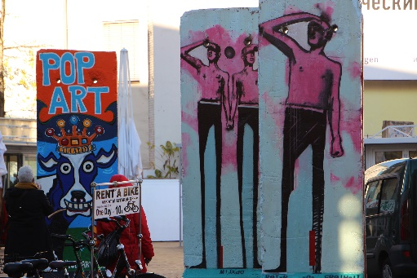
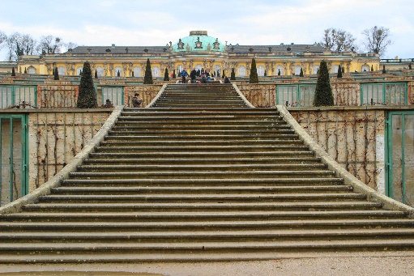
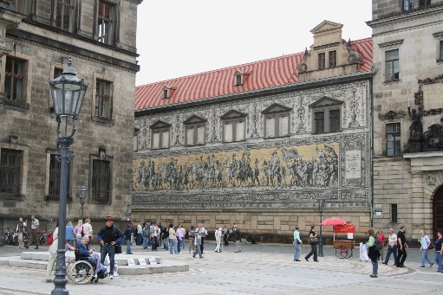
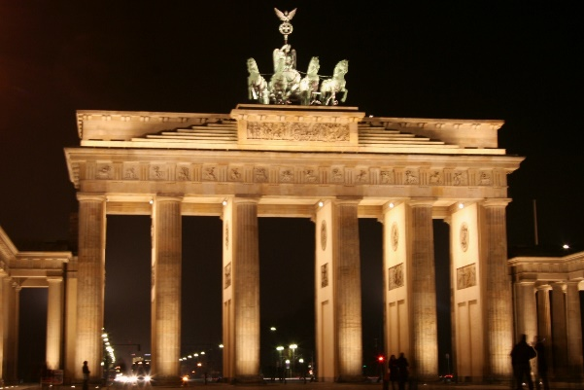
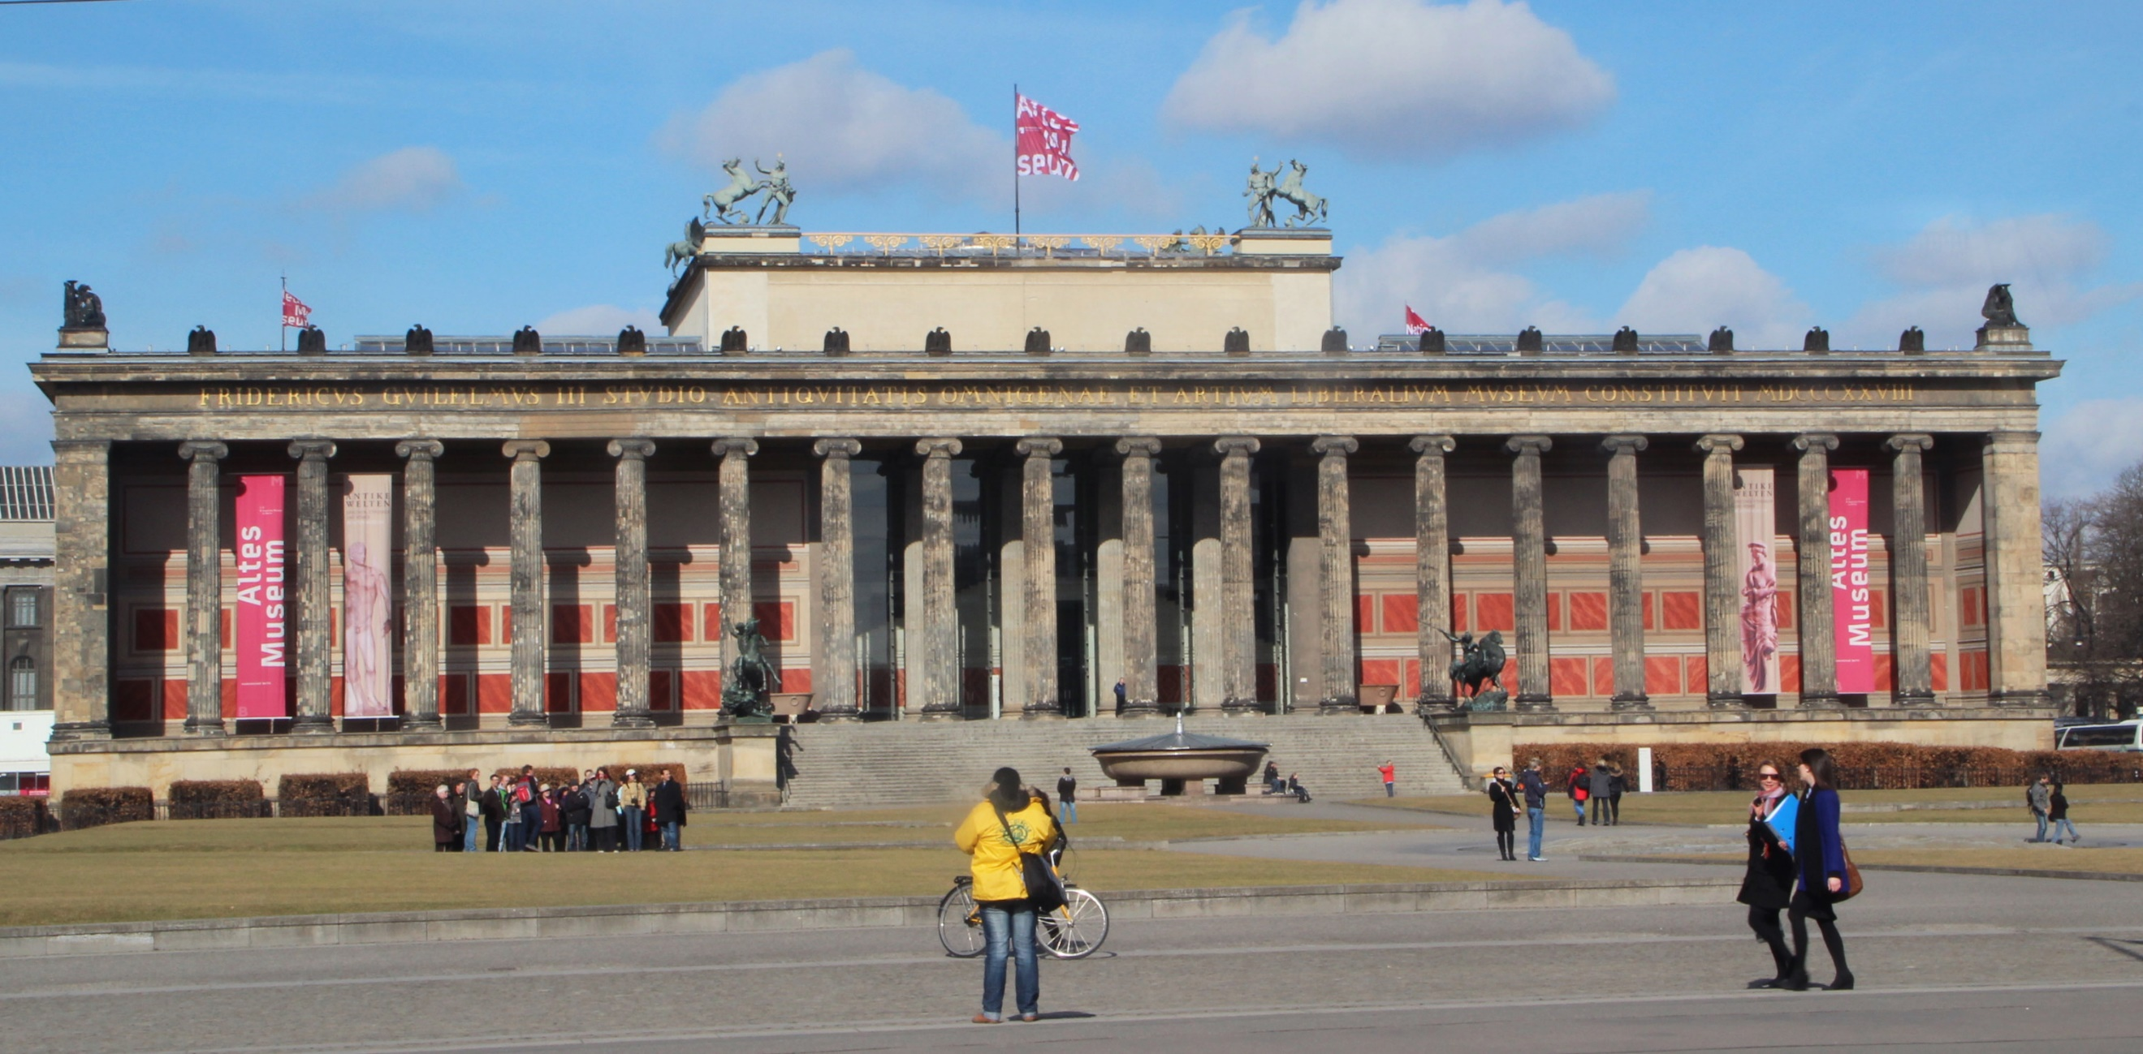
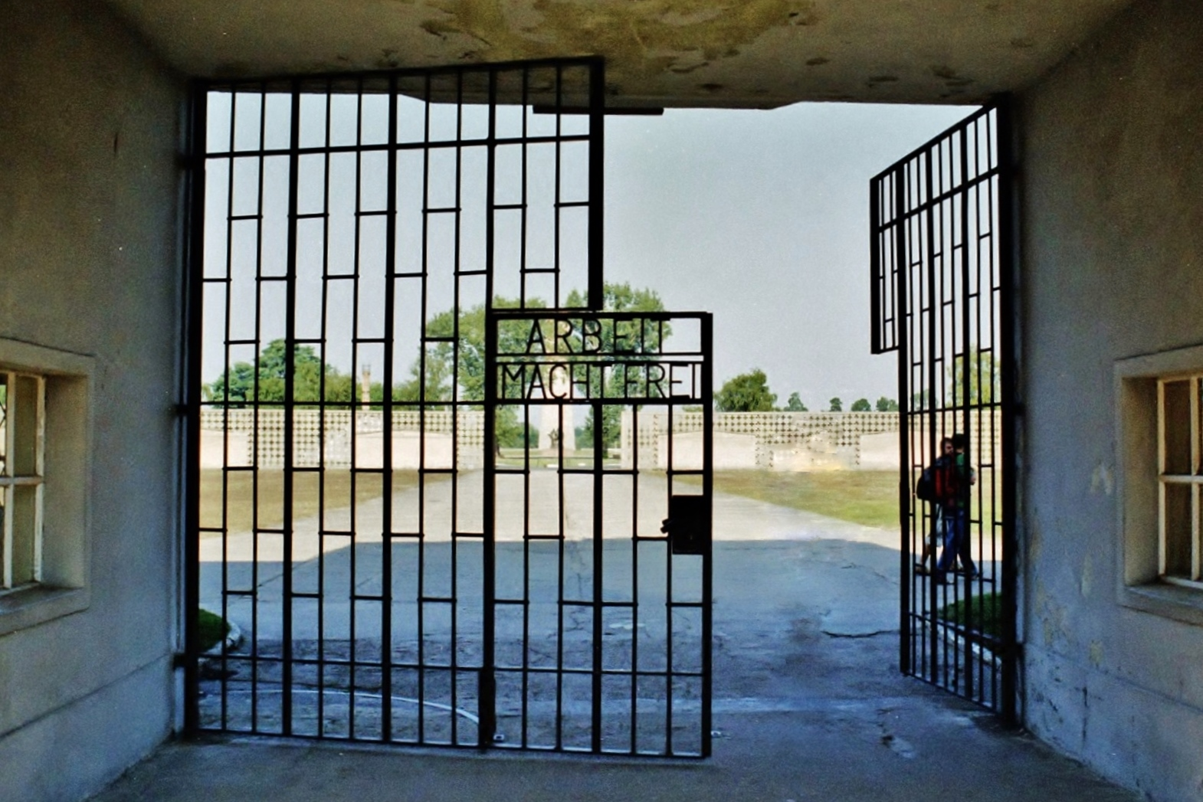
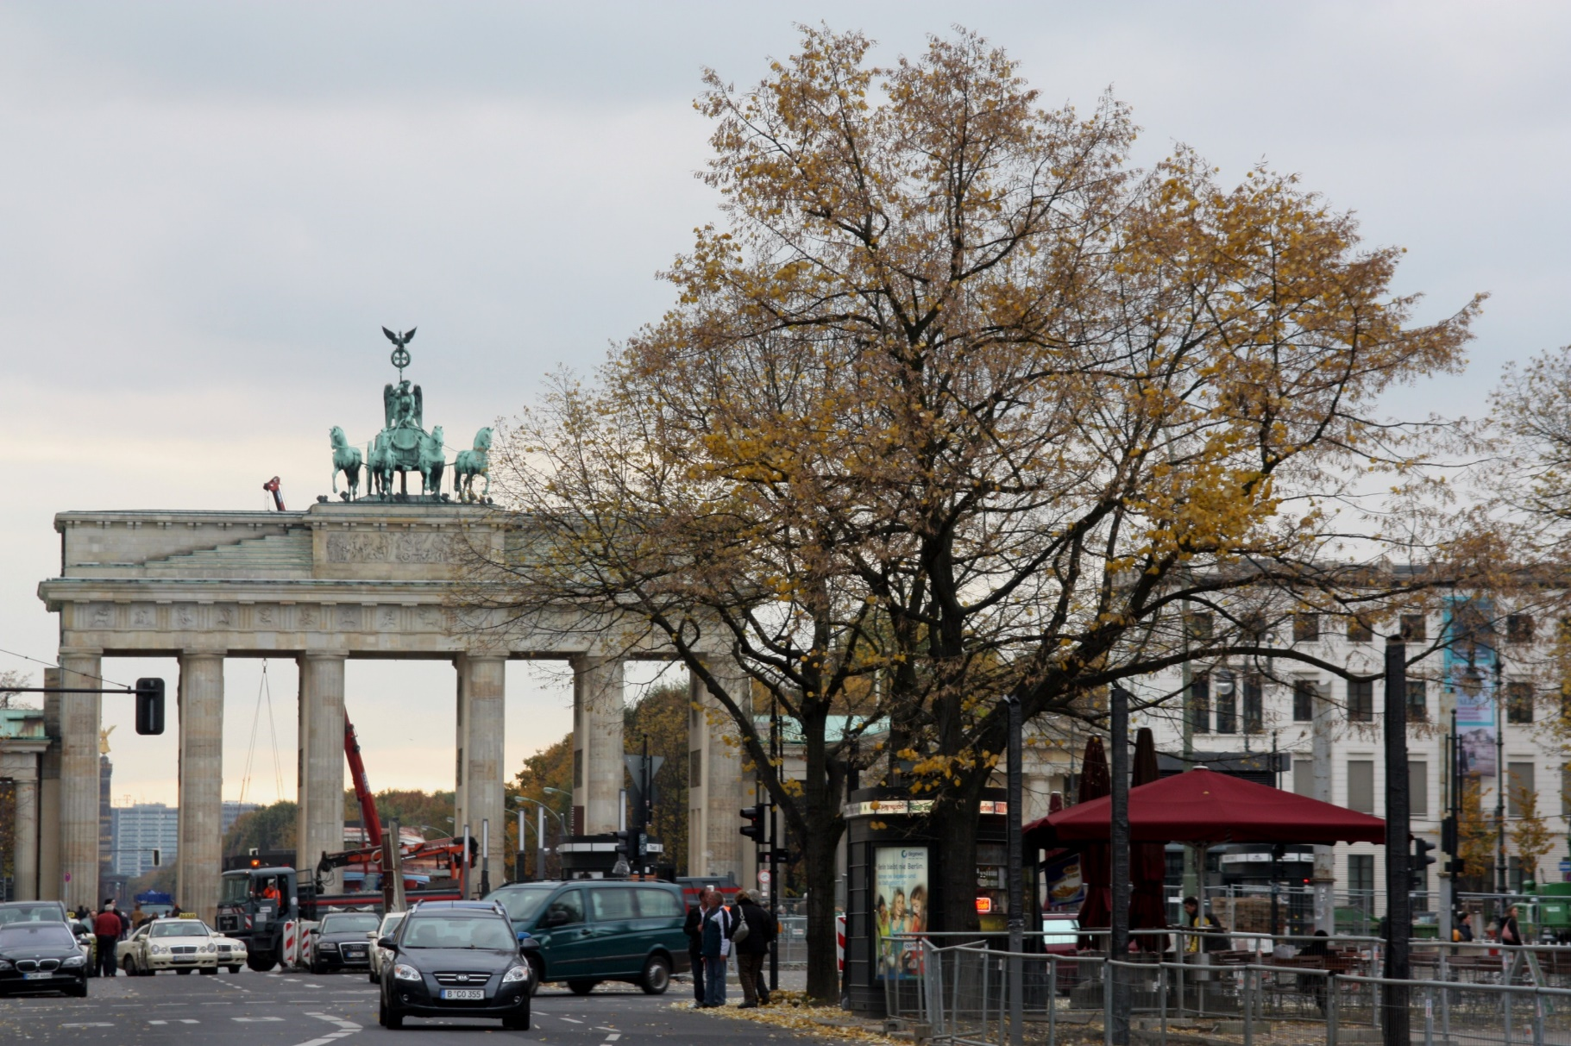
DAY 4 BREMEN - HAMBURG
Breakfast at the Hotel. Bremen is a commercial and industrial city with a major port o the river Wesser. Enjoy the morning scrolling around the city and also shopping in the fancy boutiques and department stores. In the afternoon our journey continues to Hamburg. We will pick you up at arrival and take you to the hotel. Accommodation. (B)
DAY 5 HAMBURG
Breakfast at the hotel. Hamburg is the second largest city in Germany, situated on the river Elbe and the third largest port in Europe. Take a walking tour with us around the city and harbour. The visit includes the city hall and the grand church St. Michaelis and the Warehouse. Then we will go to the harbour promenade, where we will board a boat and make a harbour tour to see the movement inside Germany's largest port. Therafter, go to the Speicherstadt, the largest warehouse district in the world where the buildings stand on timber-pile foundations, oak logs, in this particular case. It is located in the port of Hamburg—within the HafenCity quarter—and was built from 1883 to 1927. Among other things, you will find a Museum of superlatives, the Miniatur Wunderland, the largest model railway in the world and Hamburg's No. 1 tourist attraction. We will provide your scheduled skip the line tickets. A unique miniature masterpiece was created on an area of 1,499 square metres in around 795,000 working hours, and it continues to grow. In addition to its sophisticated technology, it impresses above all with its richness of detail. Over 265,000 figures were lovingly staged, cars and ships move through the landscapes, and even airplanes take off from Knuffingen Airport every minute. The Wunderland is a breathtaking miniature cosmos that cannot be seen anywhere else in the world. In the evening, you may visit a Musical (eg The Lion King or Tarzan, in German, not included in the price). Overnight. (B)
DAY 6 HAMBURG - BERLIN
After breakfast, depart for the Federal Capital of Germany. Once in Berlin, transfer on a private vehicle and accommodation at the Hotel. Berlin is the largest city in Germany. After the Second World War was divided into four districts shared by the Allies who took the administrative responsabilities for the city. Since 1961 divided through a wall and since 1989 unified again. Afternoon tour in private coach visiting the most important attractions, the Brandenburg Gate, the German Parliament (Reichstag), and the famous Kurfürstendamm. We will also have the chance to see part of the (in)famous wall. Time for shopping. Overnight. (B)
DAY 7 BERLIN - POTSDAM - BERLIN
Breakfast at the hotel. Today we will offer you a guided tour to the city of Potsdam, the capital of the State of Brandenburg, south from Berlin Center. Potsdam has several claims to national and international notability. In Germany, it had the status Windsor has in Britain because it was residence of Prussian kings and German Kaisers, until 1918. Around the city there are a series of interconnected lakes and unique cultural landmarks, in particular the parks and palaces of Sanssouci, the largest World Heritage Site in Germany, place that is included in our city tour. After visiting the park, return to Berlin.
In the afternoon, the Concentration Camp of Sachsenhausen is in our program on a guided tour, blind witness of the horror of the second World War and the Nazi Regime. Back to Berlin. In the evening, you can go for example to the Philharmonic or have drinks at Potsdam Square (Potsdamer Platz) or the Sony Center (not included) (B)
DAY 8 BERLIN
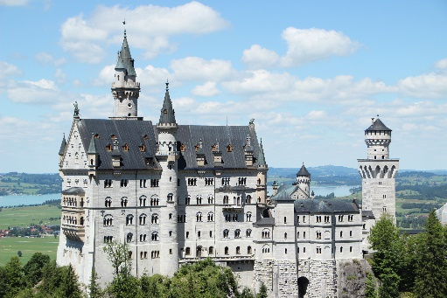
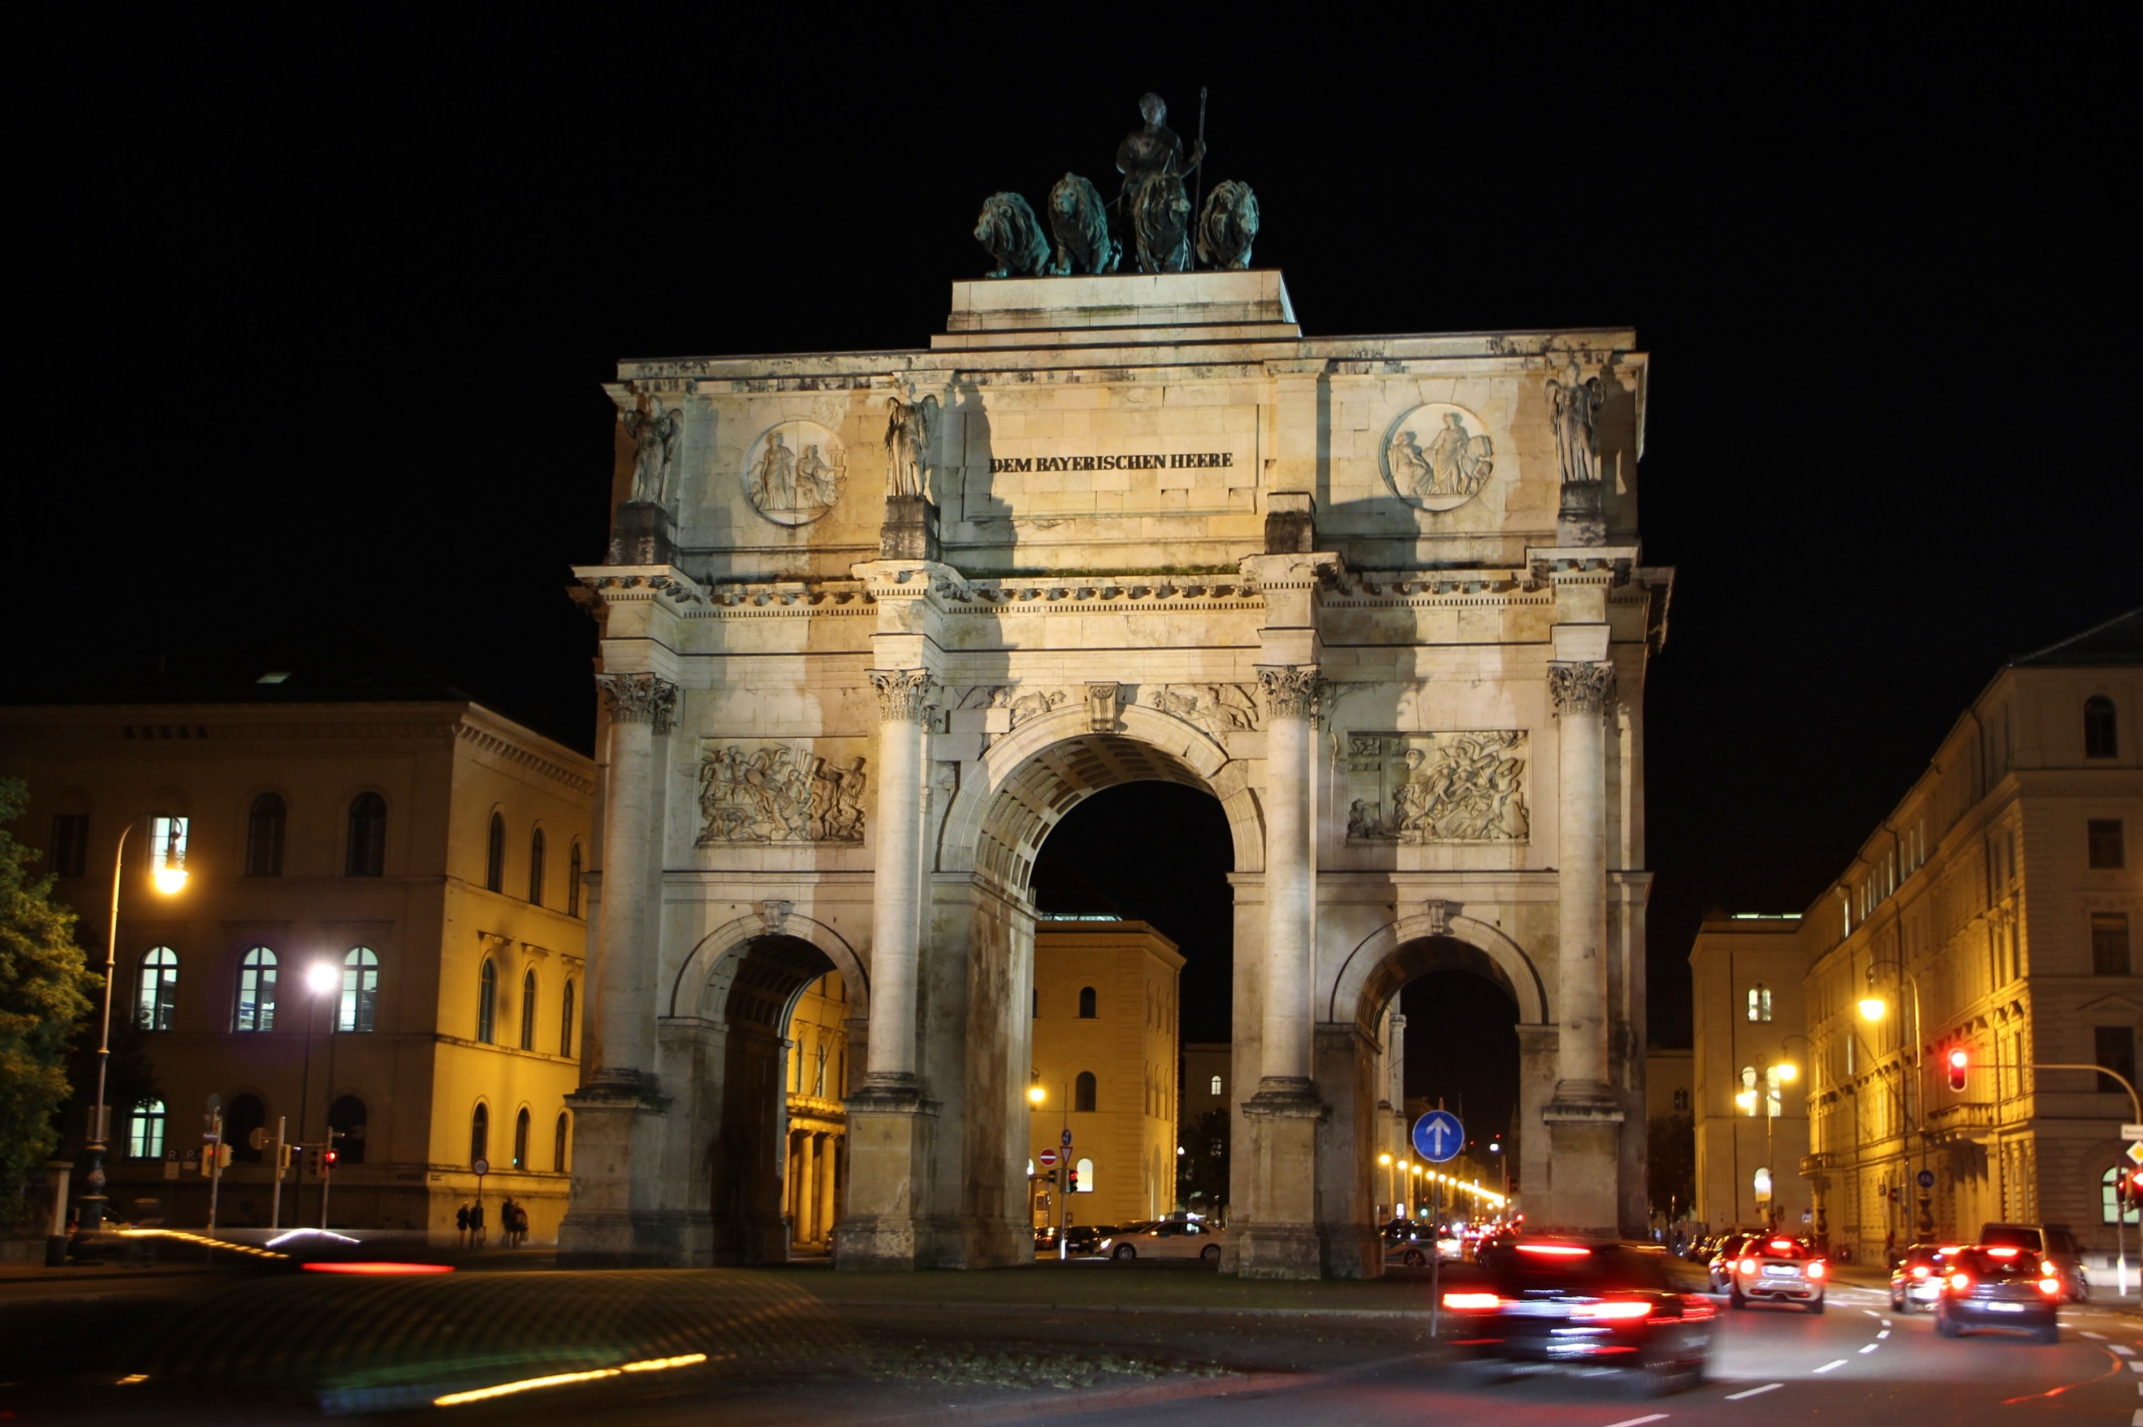
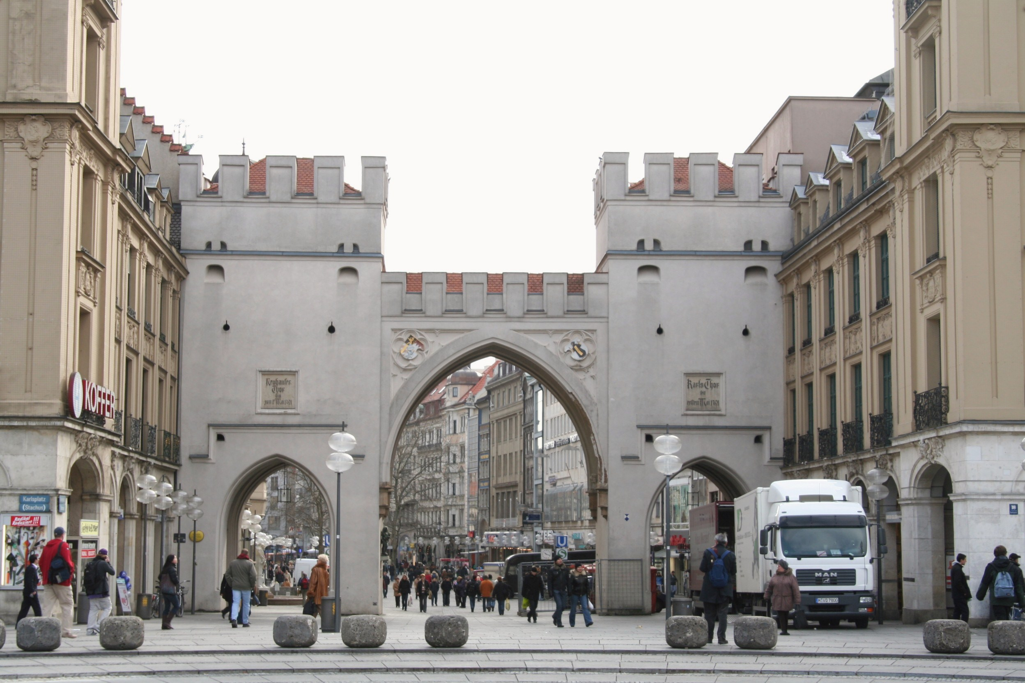
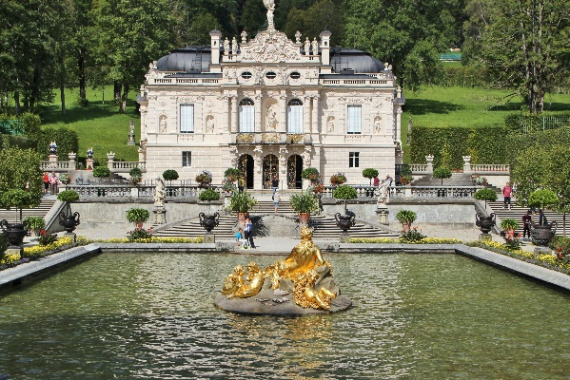
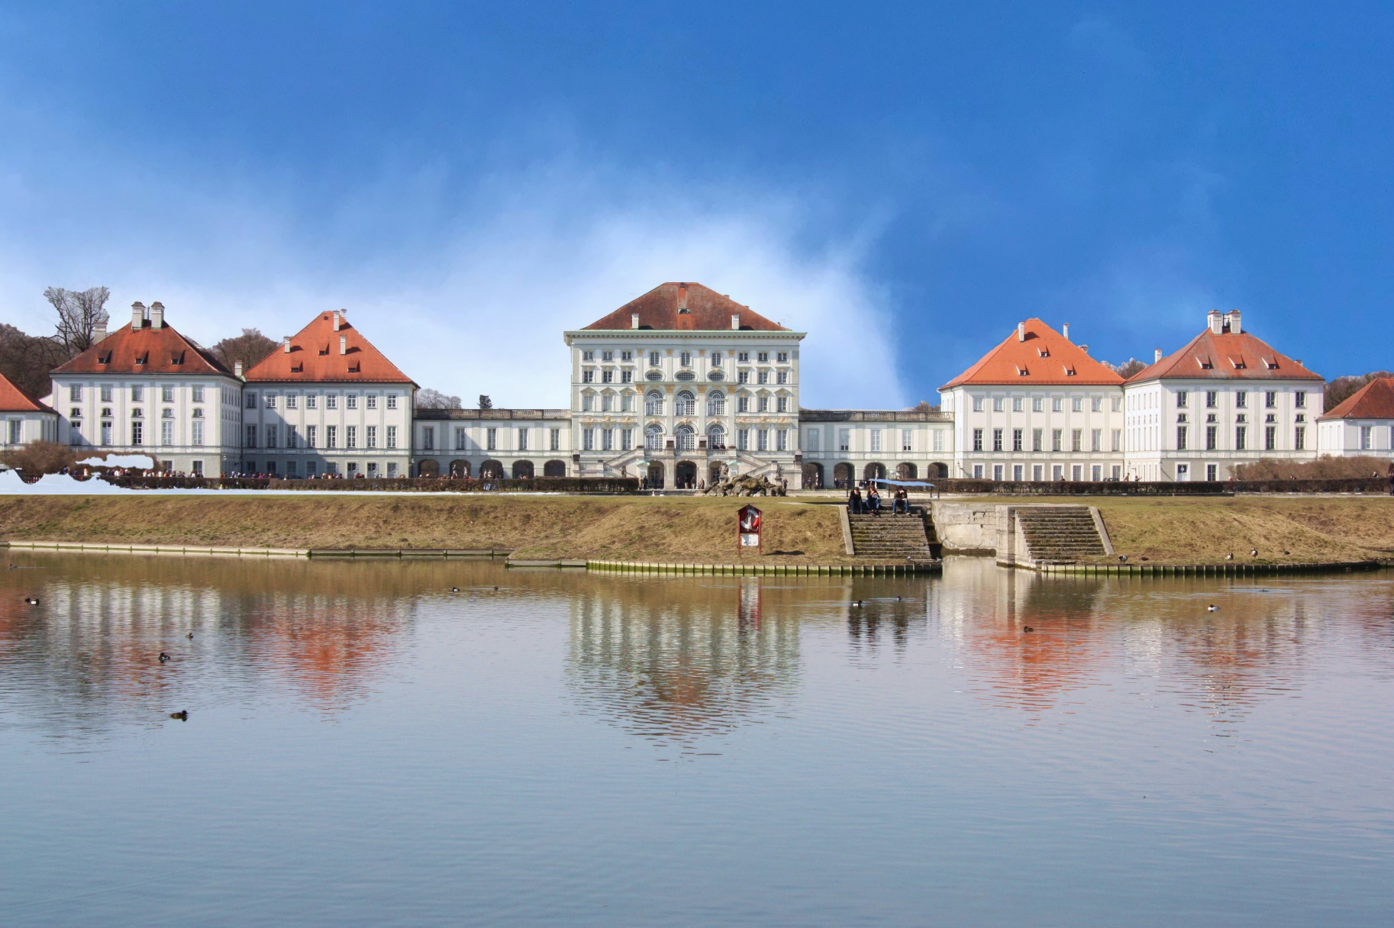
Breakfast at the hotel. You have the day at leisure because there are too many things to do in Berlin. You can stroll through the old East Berlin, the Cathedral, the Town Hall and the TV tower for a panoramic view of the city. Go to some of the many museums in the city. Suggestion: visit the Jewish Museum or the Wall Park to see the silent witnesses of the post war time in the divided city. But the most important thing to do is to visit the Museum Island, museum complex on the northern part of the Spree Island in the historic heart of Berlin. It is one of the capital's most visited sights and one of the most important museum sites in Europe. Another idea is to go out of the city and head to Dresden, in eastern Germany. Dresden has a long history as the capital and royal residence of the Electors and Kings of Saxony, who for centuries furnished the city with cultural and artistic splendor. The city was known as the Jewel Box, because of its baroque and rococo city center. We'll explore the immaculately restored Old Town including the famous Church of Our Lady (Frauenkirche), the Semper Opera House, the 'Balcony of Europe' - once Dresden's defensive rampart on the River Elbe, and the Zwinger medieval fortress - home to the Old Masters Collection featuring works by Raphael, Rembrandt, Rubens and more). Hear stories of Dresden at the medieval times, on to horrific wartime experiences, the Communist era and also discover the vibrant city of today - enjoy free time to visit the world class museums, relax on the waterfront, or stroll through the flea market. In the afternoon return to Berlin. Overnight. (B)
DAY 9 BERLIN - MUNICH
Breakfast. Departure towards Munich, the capital of the state of Bavaria. largest city in Germany, behind Berlin and Hamburg. Its native name, München, is derived from the Old High German Munichen, meaning "by the monks‘place". The city's name derives from the monks of the Benedictine order who founded the city; hence, the monk depicted on the city's coat of arms. Once in the city, transfer on private vehicle to your hotel. Later on, walk through the historic city center, including Karlstor Gate, the Cathedral of Munich (Frauenkirche), the Odeon Square and Marienplatz (Marien Square) where the city hall is located. (B)
DAY 10 MUNICH
After breakfast, leave the hotel on a guided tour to visit the most visited monument in Germany, the Neuschwannstein Palace. Departing from Munich, you’ll first visit Linderhof Castle, a French rococo-style castle inspired by Versailles itself and surrounded by immaculately manicured gardens. A quick shopping and photo stop in the charming village Oberammergau will recharge your batteries for the second half of your day. You’ll arrive at idyllic Neuschwanstein Castle around 1:00 p.m, where you’re free to enjoy approximately 4 hours to explore the castle. Wander through the scenic German countryside on your way to the legendary extravagance of the German castles Neuschwanstein and Linderhof. Known for their elaborate construction and world-famous architecture, these two extraordinary structures were dreamed up by Germany’s own Ludwig II, also known as the Swan King. You’ll soon find out why many believe Neuschwanstein inspired Disney’s storybook castles -get ready to feel like you’re living a real-life fairy tale. Hidden in the seclusion of the mountains, German King Ludwig II built two of his dream castles: Neuschwanstein and Linderhof. Both testify to the vision of Bavaria’s fairytale King. Return to Munich. Overnight. (B)
DAY 11 MUNICH - AIRPORT
Breakfast at the Hotel. Before leaving the airport for your flight back home, we will have time to see the city again, go shopping or do another tour. We suggest you to visit Nymphenburg Castlle to complete your vision of Germany. After check-in at the airport, end of our services. (B)
(B) Breakfast (L) Lunch (D) Dinner

